Material Science
Topics and Study Guide for Solid Structure

1. Tausonite, a mineral composed of Sr, O, and Ti, has the cubic unit cell shown below.
a.) What is the chemical formula of this mineral? (The Ti atom is difficult to see
but is at the [ ½ ½ ½ ] position)
b.) The Ti atom’s coordination number is 6 because it is bonded to 6 oxygen
atoms. What would the coordination number for Sr be?
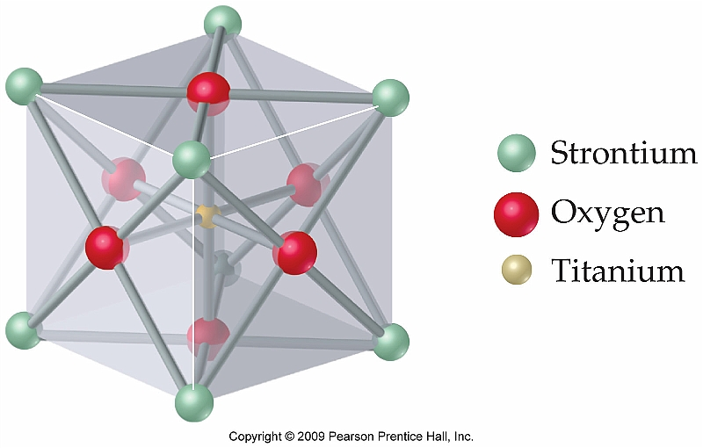

2. An element crystallizes in a body-centered cubic lattice. The edge of the unit cell is 2.86 Å, and the density of the crystal is 7.92 g/cm³. Calculate the atomic weight of the element.

3. Be familiar with the relationships between atomic radius and unit cell edge length for: Simple cubic, BCC, and FCC crystal structures.

4. Barium has a BCC crystal structure and a molar mass of 137.33 g/mol. If the density of Ba is 3.5 g/cm³ what is the atomic radius of this metal?

5. Be familiar with the following crystal systems: Cubic, Tetragonal, Orthorhombic, Trigonal

6. What are the indices for the directions depicted in the unit cell shown below? The dashed line has been given as an example.

[ 0 0 0 ]
[ 2 0 1 ]

7. Sketch a rough diagram depicting a Schottky defect in a single face centered tetragonal unit cell. The cation vacancy occurs at [ ½ ½ ½ ] position and the anion vacancy is located at the [0 1 1 ] position.

8. Sketch a rough diagram depicting a Frenkel defect in a single body centered trigonal unit cell. The anion vacancy occurs at the [ 1 1 0 ] position and the cation interstitial is located at approximately the [ ¼ ¾ ¾ ] position.

9. Refer to Question 4.4 on page 106 of your textbook. Be able to answer questions similar to this and also justify your answers using the Hume-Rothery rules.

10. Refer to Questions 4.1 & 4.3 for sample problems related to the number of vacancies as a function of temperature.

